
K L (Deemed to be) University
DEPARTMENT OF COMPUTER SCIENCE AND INFORMATION TECHNOLOGY
PROJECT REPORT
SYMPTOM-TO-DIAGNOSIS MATCHER
Submitted for the partial fulfilment of the requirements of
Data Structures and Algorithms - 3 (25CS2103E)
Academic Year 2026–2027
Submitted by
Student Name | Roll Number
Pavan Kumar | 2520090200
Rishi | 2520090131
Batch no 36
Under the Guidance of
Chandusha Kanda
Head of the Department
Dr. Khaja Shareef
Hyderabad, Telangana, India

DECLARATION
We hereby declare that the project report entitled “Symptom-to-Diagnosis Matcher” is a bonafide work carried out by Pavan Kumar (2520090200) and Rishi (2520090131) as part of the requirements for the course Data Structures and Algorithms - 3 (25CS2103E), during the academic year 2026–2027.
The project demonstrates the application of data structures, searching, matching, scoring, and ranking algorithms to a symptom-to-condition matching problem. The system is developed for academic purposes and is not intended to replace professional medical examination, laboratory testing, or clinical diagnosis.
We further declare that the work presented in this report is our own academic work and that appropriate acknowledgement has been given wherever external resources have been consulted.
Name | Roll Number
Pavan Kumar | 2520090200
Rishi | 2520090131

CERTIFICATE
This is to certify that the project report entitled “Symptom-to-Diagnosis Matcher” is a bonafide work carried out and submitted by Pavan Kumar (2520090200) and Rishi (2520090131), in partial fulfilment of the requirements for the course Data Structures and Algorithms - 3 (25CS2103E), K L (Deemed to be) University, during the academic year 2026–2027.
The project has been completed under the guidance of Chandusha Kanda and is submitted for academic evaluation.
Project Guide: Chandusha Kanda
Head of the Department: Dr. Khaja Shareef
External Examiner: ______________________________

ACKNOWLEDGEMENT
We express our sincere gratitude to K L (Deemed to be) University for providing the academic environment and facilities required to complete this project.
We are especially grateful to our project guide, Chandusha Kanda, for her valuable guidance, encouragement, constructive feedback, and continuous support throughout the development of the Symptom-to-Diagnosis Matcher.
We also express our sincere thanks to Dr. Khaja Shareef, Head of the Department of Computer Science and Information Technology, for his support and for providing the necessary academic direction and facilities.
Finally, we thank the faculty members, classmates, friends, and everyone who contributed directly or indirectly to the successful completion of this project.

TABLE OF CONTENTS
S.No. | Contents | Page No.
1 | Abstract | 6
2 | Introduction | 7
3 | Literature Survey | 8
4 | Problem Statement and Objectives | 9
5 | Hardware and Software Requirements | 10
6 | Implementation | 11
7 | Results and Discussion | 12
8 | Conclusion and Future Scope | 13
9 | References | 14

1. ABSTRACT
The Symptom-to-Diagnosis Matcher is an academic decision-support prototype designed to match a user's entered symptoms with a predefined collection of medical conditions and rank the most relevant possible matches. The project demonstrates how data structures and algorithms can be applied to a real-world information-matching problem.
The system accepts one or more symptoms as input, represents symptom–condition relationships in a structured form, compares the user's symptoms with stored condition profiles, calculates a matching score, and presents candidate conditions in ranked order. The approach focuses on efficient searching, set-based matching, scoring, and sorting.
The project is designed as an educational prototype rather than a clinical diagnostic tool. In a real healthcare system, validated clinical datasets, expert review, privacy controls, and appropriate regulatory requirements would be necessary. Therefore, the output of this project must be interpreted only as possible matches for academic demonstration.
Team Members: Pavan Kumar (2520090200) and Rishi (2520090131).

2. INTRODUCTION
Identifying possible medical conditions from a collection of symptoms is a complex information-matching problem. A user may enter several symptoms, while each condition can be associated with a different combination of symptoms. A computational system can organize these relationships and compare an input symptom set against stored condition profiles.
The Symptom-to-Diagnosis Matcher addresses this problem by converting symptoms and condition profiles into structured data and applying a matching algorithm. Instead of presenting an unstructured list, the system ranks candidate conditions according to how closely their symptom sets correspond to the user's input.
Project Workflow
- Collect symptom inputs from the user.
- Normalize and represent the selected symptoms in a structured form.
- Retrieve condition profiles and their associated symptoms.
- Compare the user's symptom set with each condition's symptom set.
- Calculate a matching score based on symptom overlap.
- Rank candidate conditions using the computed scores.
- Display ranked results with an appropriate safety notice.
Scope
- Educational demonstration of data structures and algorithms.
- Fast matching between user symptoms and stored condition profiles.
- Ranking of candidate conditions based on symptom overlap.
- Expandable design for additional symptoms and conditions.
- No claim of clinical diagnosis or treatment recommendation.

3. LITERATURE SURVEY
Existing healthcare information systems demonstrate the value of structured symptom and disease information, but a symptom-matching prototype must distinguish between information retrieval and clinical diagnosis. The following resources provide background for organizing condition and symptom information.
Reference Source | Relevance to Project
MedlinePlus | Patient-oriented health information covering diseases, symptoms, medicines, and health topics.
Mayo Clinic | Structured information about symptoms, diseases, causes, and treatments.
World Health Organization | Authoritative public-health information and disease-related resources.
NHS | Patient-facing information on symptoms and health conditions with emphasis on clear communication.
CDC | Public-health information and educational resources covering diseases, symptoms, prevention, and health risks.
The project focuses specifically on the algorithmic layer: representing symptom-condition relationships, comparing symptom sets, computing match scores, and ranking candidate results in an explainable way.

4. PROBLEM STATEMENT AND OBJECTIVES
Problem Statement
To design and implement an efficient algorithmic system that accepts a set of user-reported symptoms, compares them with structured symptom profiles of known conditions, and ranks the most closely matching conditions.
Problem Description
Users may have difficulty organizing multiple symptoms and identifying which stored condition profiles share the greatest overlap. The proposed system automates the matching and ranking process while presenting the output as possible matches rather than confirmed medical diagnoses.
Objectives
- Represent symptoms and condition profiles using suitable data structures.
- Implement an efficient symptom-matching mechanism.
- Calculate a transparent matching score from symptom overlap.
- Rank candidate conditions according to their matching scores.
- Provide clear and understandable output to the user.
- Demonstrate searching, hashing/set operations, sorting, and algorithmic analysis.
- Maintain a safety boundary by presenting results as possible matches, not medical diagnoses.
Expected Outcome
The expected outcome is a functional prototype that accepts symptoms, performs matching against the available condition dataset, and produces a ranked result list that can be explained in terms of the matching algorithm.

5. HARDWARE AND SOFTWARE REQUIREMENTS
Hardware Requirements
- Laptop/Desktop computer
- Minimum 4 GB RAM; 8 GB or more recommended
- Dual-core processor or better
- At least 500 MB of free storage
- Keyboard and mouse
Software Requirements
- Windows / Linux / macOS
- Visual Studio Code or equivalent IDE
- Programming environment appropriate to the implementation language
- Git and GitHub for version control
- Structured symptom-condition dataset
Functional Requirements
- Accept one or more symptoms from the user.
- Match symptoms against stored condition profiles.
- Compute a matching score.
- Sort and display candidate conditions.
- Provide a clear safety disclaimer.
Non-Functional Requirements
- Efficiency in repeated symptom membership checks.
- Simple and understandable user interaction.
- Maintainable symptom-condition data.
- Transparent and explainable result ranking.

6. IMPLEMENTATION
The implementation is organized into modules so that input handling, data storage, matching, scoring, and result presentation remain logically separated.
Module 1 – Symptom Input and Normalization
Accepts symptoms from the user and converts them into a consistent representation so that equivalent symptom labels can be matched reliably.
Module 2 – Condition Data Management
Stores each condition with its associated symptom set. A hash-based or set-based representation supports efficient membership checks.
Module 3 – Symptom Matching and Scoring
Compares the user's symptom set with each condition's symptom set and calculates a score based on symptom overlap.
Module 4 – Ranking and Result Display
Sorts candidate conditions by score and presents the highest-scoring matches first, together with a safety notice.
Core Algorithm – Symptom Matching
- Read the user's selected symptoms into an input set S.
- For every condition C, retrieve its symptom set SC.
- Compute the intersection S ∩ SC to identify common symptoms.
- Calculate a match score using the chosen overlap formula.
- Store the condition and score as a candidate result.
- Sort candidates in descending order of score.
- Display the top-ranked candidates.
Data Structures Used
- Arrays/Lists – collections of symptoms and results.
- Hash Sets – fast symptom membership and intersection operations.
- Hash Maps/Dictionaries – mapping condition names to symptom sets.
- Sorting – ranking candidate conditions by score.
Algorithmic Complexity
For a set-based implementation, symptom membership checks are approximately O(1) on average. The overall matching cost depends on the number of stored conditions and their symptom sets, followed by the cost of sorting candidate results. The exact complexity depends on the final implementation and scoring method.

7. RESULTS AND DISCUSSION
The prototype is intended to produce a ranked list of possible condition matches for a supplied symptom set. The result is based on the similarity between the user's symptoms and the symptom profile stored for each condition.
Illustrative Result Format
Rank | Candidate Condition | Matched Symptoms | Match Score
1 | Condition A | High overlap | Highest
2 | Condition B | Moderate overlap | Medium
3 | Condition C | Lower overlap | Lower
The table above is an illustrative presentation format. For the final submission, replace it with screenshots and actual output from the implemented prototype.
Discussion
- Set-based matching makes symptom comparison straightforward and explainable.
- Ranking lets users inspect the strongest matches first.
- The approach can later be extended with symptom weights, severity, duration, or validated clinical rules.
- A matching score alone must not be interpreted as a confirmed diagnosis.
Recommended Screenshots
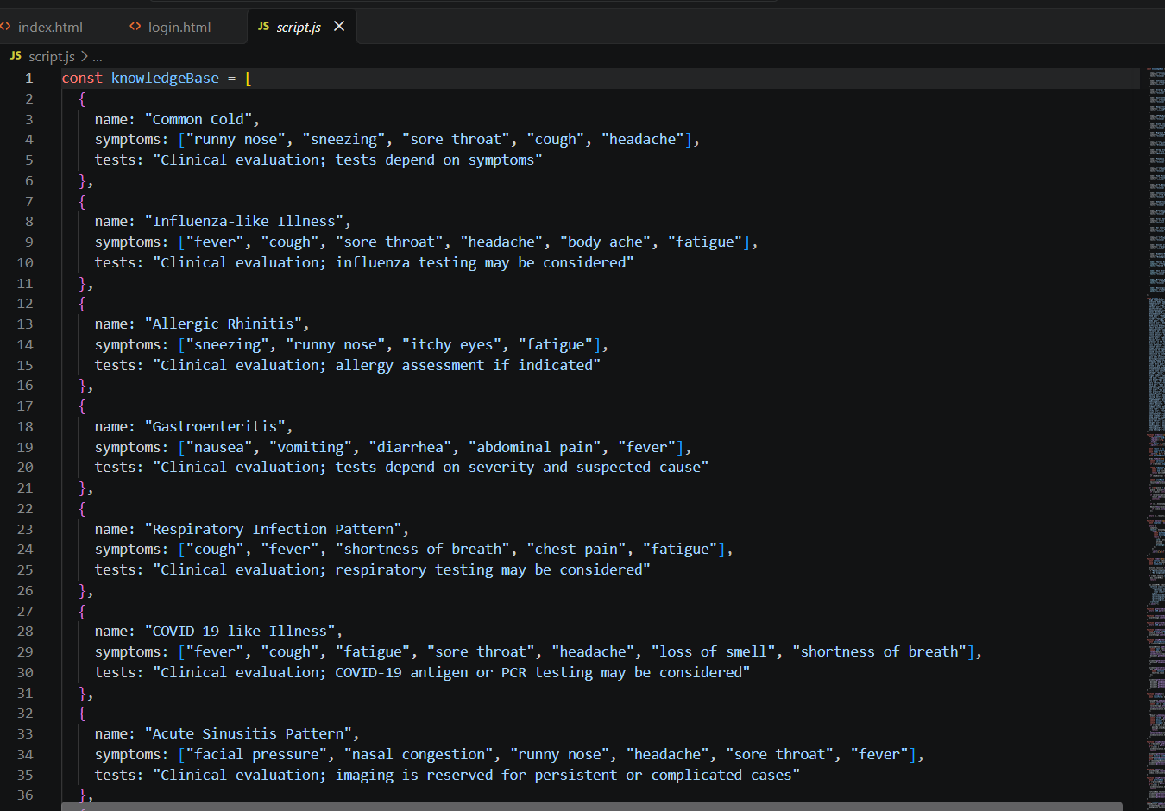

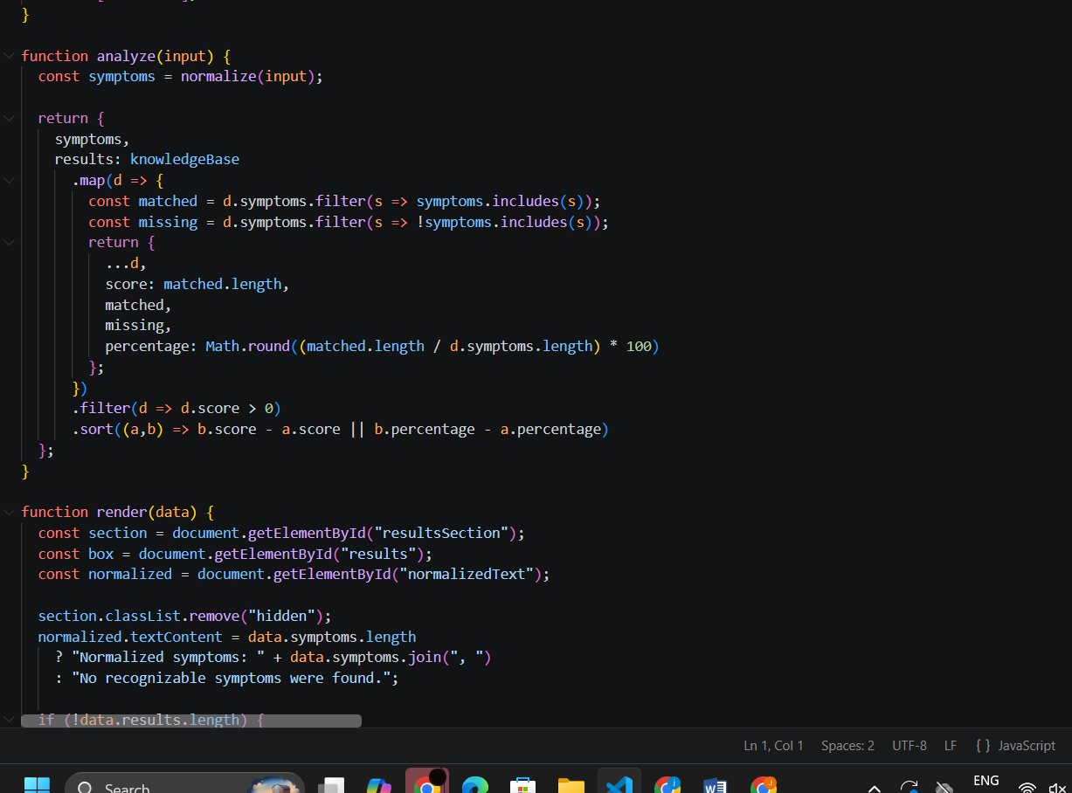
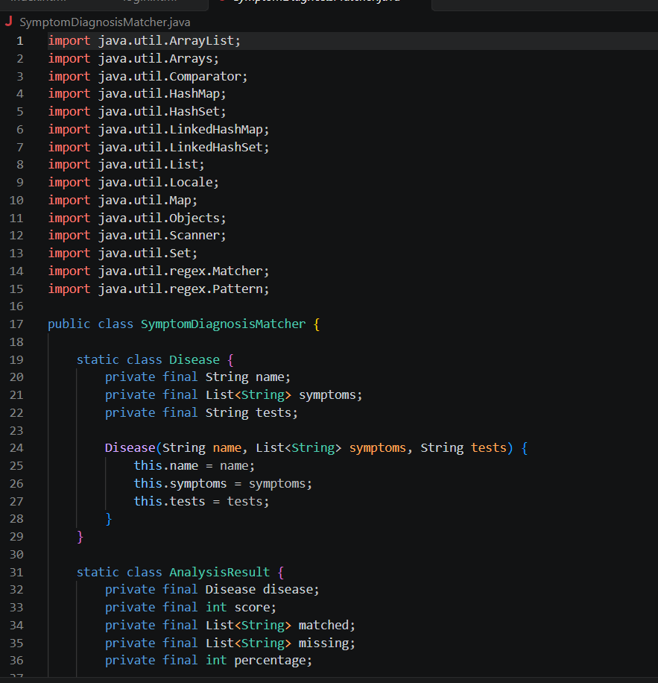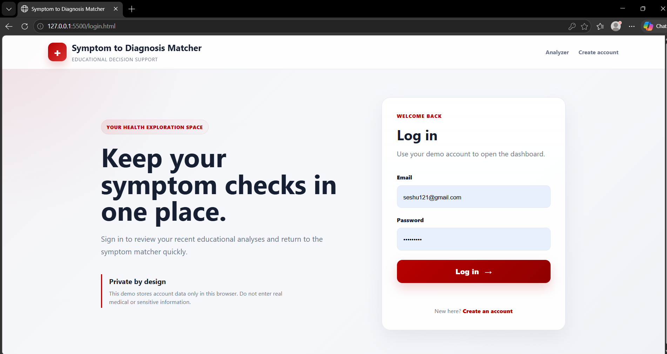
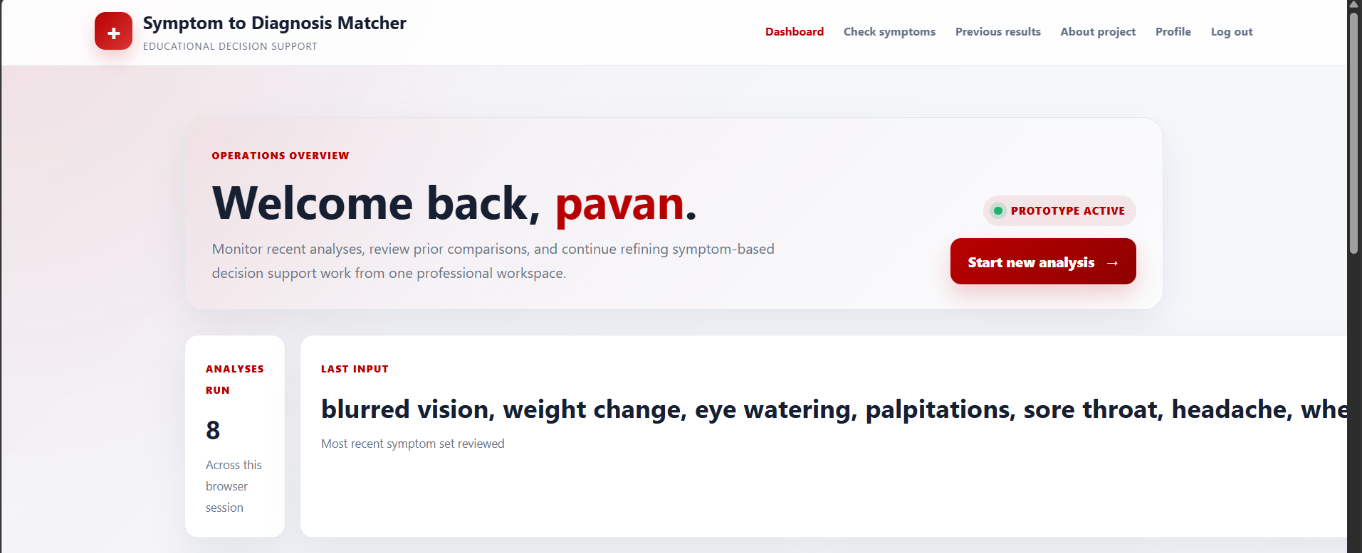
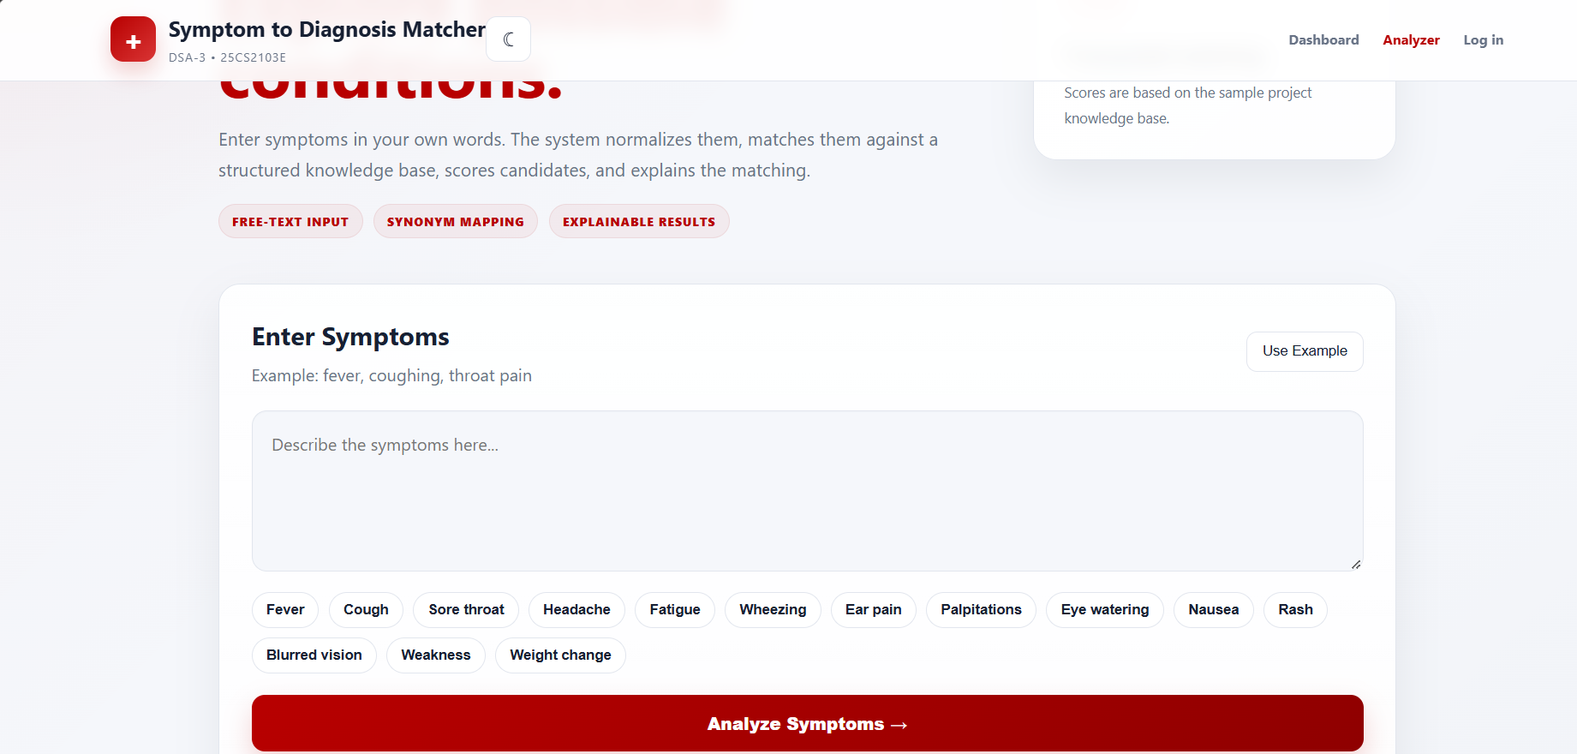
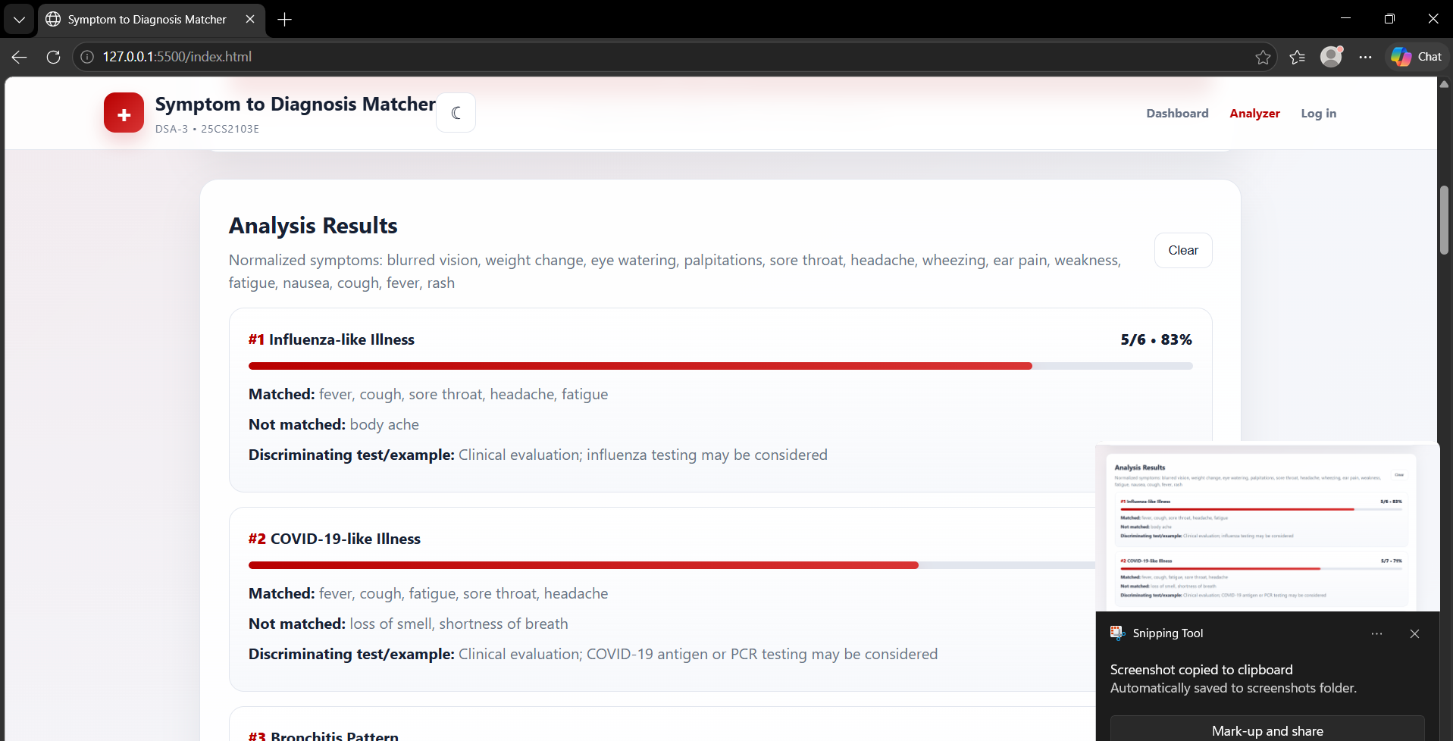

8. CONCLUSION AND FUTURE SCOPE
Conclusion
The Symptom-to-Diagnosis Matcher demonstrates how data structures and algorithms can be applied to a practical symptom-matching problem. By representing symptom-condition relationships in structured collections, calculating overlap, and ranking candidate conditions, the project provides a clear example of searching, set operations, scoring, and sorting.
The prototype is intended for academic and educational use. It should not be treated as a clinical diagnostic system because real diagnosis requires medical history, physical examination, investigations, professional judgement, and validated clinical evidence.
Future Scope
- Use a larger and professionally validated medical dataset.
- Introduce weighted symptoms based on clinical relevance.
- Add symptom severity and duration as additional input features.
- Improve normalization using medical terminology and synonym mapping.
- Add explainable result details showing why each condition was ranked.
- Add secure user authentication and privacy controls where appropriate.
- Evaluate the algorithm using precision, recall, ranking metrics, and expert review.
- Develop a mobile-friendly interface and multilingual support.

9. REFERENCES
- National Library of Medicine, MedlinePlus — https://medlineplus.gov/
- World Health Organization — https://www.who.int/
- Mayo Clinic — https://www.mayoclinic.org/
- NHS — https://www.nhs.uk/
- Centers for Disease Control and Prevention — https://www.cdc.gov/
- Python Documentation — https://docs.python.org/3/
- Java Documentation — https://docs.oracle.com/en/java/
- GeeksforGeeks, Data Structures and Algorithms — https://www.geeksforgeeks.org/data-structures/
- K L (Deemed to be) University — https://www.kluniversity.in/
PROJECT TEAM
Name | Roll Number | Contribution
Pavan Kumar | 2520090200 | Development, algorithm implementation & documentation
Rishi | 2520090131 | Development, testing & documentation

